# Add a Notification Message in Top Banner of the SharePoint Site using PowerShell

[April 03, 2019](https://www.sharepointdiary.com/2019/04/add-notification-to-sharepoint-top-banner-using-powershell.html)  [Custom Action](https://www.sharepointdiary.com/search/label/Custom%20Action?&max-results=10), [Javascript](https://www.sharepointdiary.com/search/label/Javascript?&max-results=10), [PowerShell](https://www.sharepointdiary.com/search/label/PowerShell?&max-results=10), [SharePoint](https://www.sharepointdiary.com/search/label/SharePoint?&max-results=10), [SharePoint 2013](https://www.sharepointdiary.com/search/label/SharePoint%202013?&max-results=10), [SharePoint 2016](https://www.sharepointdiary.com/search/label/SharePoint%202016?&max-results=10)

<https://www.sharepointdiary.com/2019/04/add-notification-to-sharepoint-top-banner-using-powershell.html#ixzz6GPf4TFT0>

**Requirement:** Add a message to top banner area of a SharePoint site collection

**[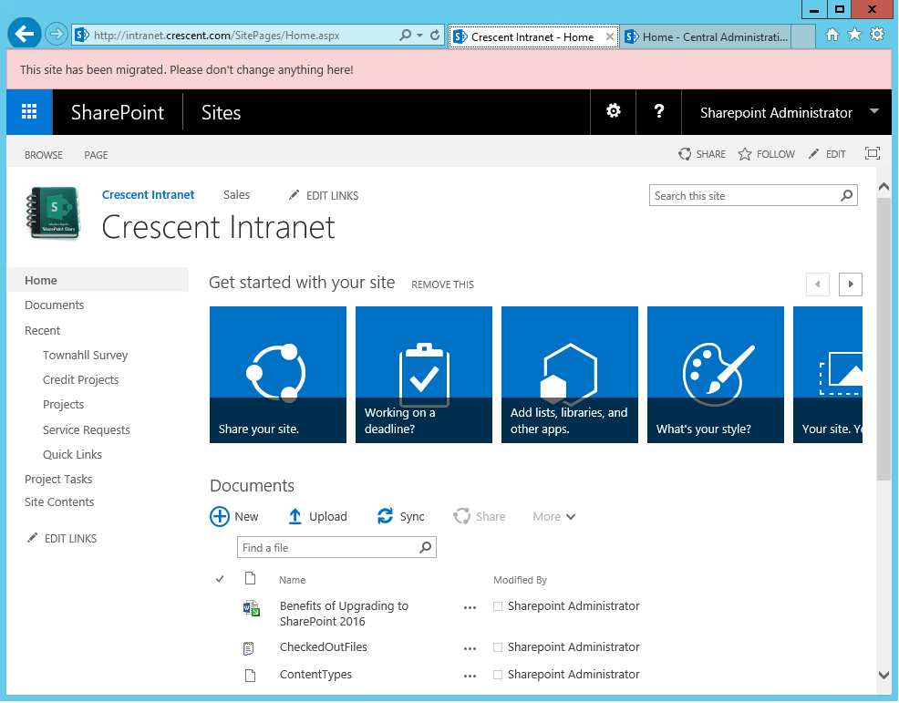](https://3.bp.blogspot.com/-Ivv_Tik49A4/XEjBGtKX-LI/AAAAAAAAPUY/WLuD0FVscw8YZrPH64OC8rZzIG22yKEjQCLcBGAs/s1600/custom%2Baction%2Bto%2Badd%2Btop%2Bbanner%2Bmessage%2Bin%2Bsharepoint%2Busing%2Bpowershell.png)**

**PowerShell to Add Site Notification Message in SharePoint:**

After the migration from SharePoint 2013 to SharePoint 2016, we wanted to add a message at the top banner of a migrated site.

|  |  |
| --- | --- |
| 1  2  3  4  5  6  7  8  9  10  11  12  13  14  15  16  17  18  19  20  21  22  23  24  25  26  27  28  29  30  31  32  33  34  35  36  37  38  39  40  41  42  43  44  45  46  47  48  49  50  51  52  53  54  55  56  57  58  59  60  61  62  63  64  65  66  67  68  69  70  71  72  73  74  75  76  77  78  79  80  81  82  83  84  85  86  87  88  89  90  91  92  93  94  95  96  97  98  99  100  101  102  103  104  105  106  107  108  109  110  111  112  113  114  115  116  117  118 | Add-PSSnapin Microsoft.SharePoint.PowerShell -ErrorAction SilentlyContinue    **Function Add-CustomAction**  {      param      (          [parameter(Mandatory=$true, ParameterSetName='Site')]          [Microsoft.SharePoint.SPSite]$Site,            [parameter(Mandatory=$true, ParameterSetName='Web')]          [Microsoft.SharePoint.SPWeb]$Web,            [parameter(Mandatory=$true, ParameterSetName='Site')]          [parameter(Mandatory=$true, ParameterSetName='Web')]          [string]$Message,            [parameter(Mandatory=$true, ParameterSetName='Site')]          [parameter(Mandatory=$true, ParameterSetName='Web')]          [string]$ActionName,            [parameter(Mandatory=$false, ParameterSetName='Web')]          [switch]$IncludeSubWebs,            [parameter(Mandatory=$true, ParameterSetName='Site')]          [parameter(Mandatory=$true, ParameterSetName='Web')]          [string][ValidateSet("Red", "Yellow", "Green", "Blue")]$BackGroundColor      )        begin      {          # To avoid quote conflicts          $Message = $Message.Replace( "`"", "'")            $startingSequence = 1100          $JavaScript = @"                function Execute_$($ActionName)_MessageBar_$($PSCmdlet.ParameterSetName)()              {                  var st = document.getElementById('$ActionName');                  if(st != null)                  {                      st.style.display = '';                      return;                  }                    st = document.createElement("div");                  st.id = "$($ActionName)_MessageBar_$($PSCmdlet.ParameterSetName)";                  st.innerHTML = "<div class='ms-status-$($BackGroundColor.ToLower())' style='padding: 12px 14px 6px; border: 1px solid; font-family: \"Segoe UI\", Tahoma, sans-serif; font-size: 13px; min-height: 24px;'>$Message</div>";                    document.body.insertBefore(st, document.body.childNodes[0]);              }                // don't show on modal dialog windows              if(!window.location.search.match("[?&]IsDlg=1"))              {                  Execute_$($ActionName)_MessageBar_$($PSCmdlet.ParameterSetName)();              }  "@      }      process      {          $customAction = $null            if( $PSCmdlet.ParameterSetName -eq "Site" )          {              Remove-CustomAction -Site $site -ActionName $ActionName | Out-Null              $customAction = $Site.UserCustomActions.Add()          }          else          {              Remove-CustomAction -Web $Web -ActionName $ActionName | Out-Null              $customAction = $Web.UserCustomActions.Add()          }            $customAction.Location    = "ScriptLink"          $customAction.Sequence    = $startingSequence          $customAction.Title       = $ActionName          $customAction.ScriptBlock = $JavaScript          $customAction.Update()            if( $IncludeSubWebs )          {              foreach($w in $Web.Webs)              {                  Add-CustomAction -Web $w -Message $Message -ActionName $ActionName -IncludeSubWebs -BackGroundColor $BackGroundColor              }          }      }      end      {      }  }  **Function Remove-CustomAction**  {      param      (          [parameter(Mandatory=$true, ParameterSetName='Site')]          [Microsoft.SharePoint.SPSite]$Site,            [parameter(Mandatory=$true, ParameterSetName='Web')]          [Microsoft.SharePoint.SPWeb]$Web,            [parameter(Mandatory=$true, ParameterSetName='Site')]          [parameter(Mandatory=$true, ParameterSetName='Web')]          [string]$ActionName      )        begin      {          $existingActions = @()      }      process      {          if( $PSCmdlet.ParameterSetName -eq "Site" )          {              $Site.UserCustomActions | ? { $_.Title -eq $ActionName } | % { $existingActions += $_ }              $existingActions | % { $Site.UserCustomActions.Item($_.Id).Delete() }          }          else          {              $Web.UserCustomActions | ? { $_.Title -eq $ActionName } | % { $existingActions += $_ }              $existingActions              $existingActions | % { $Web.UserCustomActions.Item($_.Id).Delete() }          }      }      end      {      }  }  $Site = Get-SPSite -Identity "https://intranet.crescent.com/"  Add-CustomAction -Site $site -Message "This site has been migrated to SharePoint 2016. Please don't change anything here!" -ActionName "SiteMovedBanner" -BackGroundColor Red |

## Set a notification at web level, use:

|  |  |
| --- | --- |
| 1 2 | $web = Get-SPWeb -Identity "https://intranet.crescent.com/sites/marketing/us"  Add-CustomAction -Web $web -Message "This site has been migrated to SharePoint 2016. Please don't change anything here!" -ActionName "WebMovedBanner" -BackGroundColor Yellow -IncludeSubWebs |

## Remove the Custom action, use:

|  |  |
| --- | --- |
| 1 | Remove-CustomAction  -Site $site -ActionName "SiteMovedBanner" |

<https://www.sharepointdiary.com/2019/04/add-notification-to-sharepoint-top-banner-using-powershell.html#ixzz6GPf4TFT0>